3. Smartphone Application

3.1 User interface/application states

3.1.1 Flow Diagram

A flow diagram for navigating the smartphone application is shown below (the arrow without origin signifies opening the app).

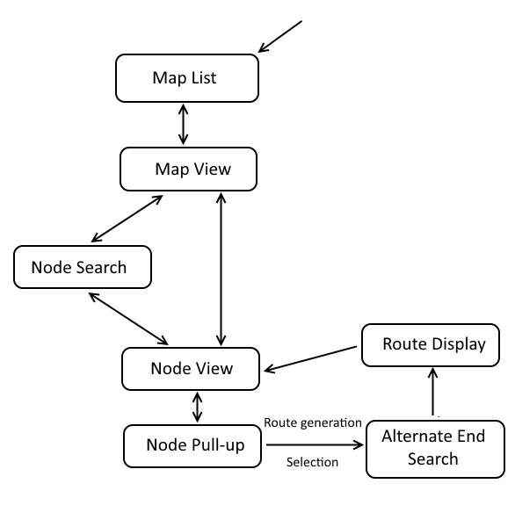

3.1.2 Map List

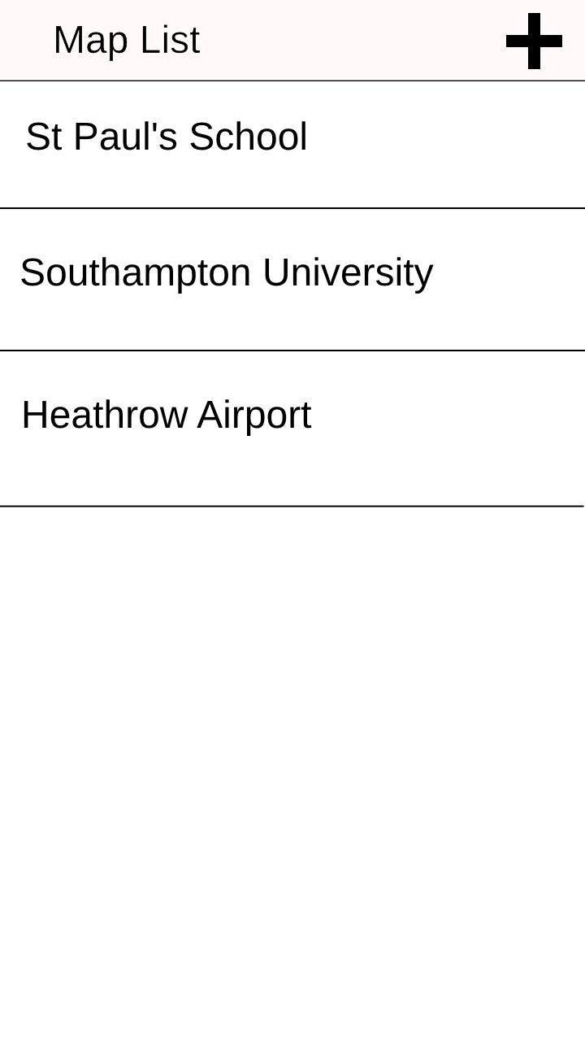

Upon opening the app, a page resembling this is presented. The ‘list’ section (excluding the header bar) can be vertically scrolled if too many locations are displayed.

* Upon tapping the plus icon, the user would be prompted to add a layout (by entering a URL into a text box), and assuming that the URL is valid and leads to a valid layout, download the hosted layout and add it to the list. Note: the same effect occurs if the device, outside of application operation, attempts to open a ‘.lay’ file (see section 1.2.1, ‘Save Project’ dialogue) by way of an Android intent filter.
* Upon clicking a location, the app loads the respective layout into memory from storage (see section 1.1.3) and transitions to the **Map View** page.

3.1.3 Map View

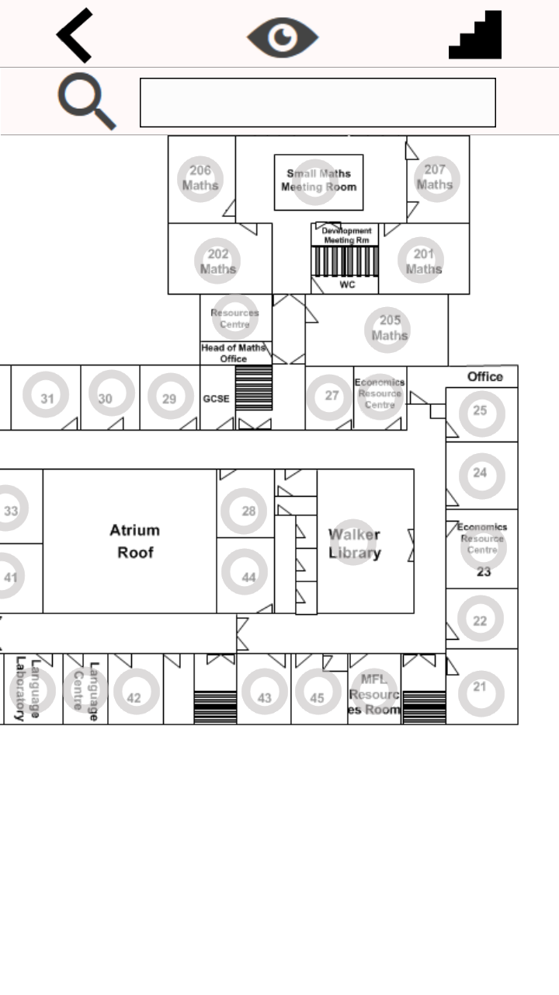

The Map View page features two stationary header bars and a ‘map’ section which can be pinch-zoomed and scrolled, showing the layout map of the building (of a particular floor) with circular nodes representing (visible) rooms overlaid on the layout.

* Upon tapping the left-arrow icon, the app generally transitions back to the previous page (here, the **Map List** page).
* Upon tapping the eye icon, the circular nodes disappear to show only the background map (tapping the icon again shows them again).
* Upon tapping the stairs icon, a slider appears allowing the user to select the floor displayed.
* Upon tapping a circular node, the node is displayed in the **Node View** pane.
* Upon tapping either the magnifying glass icon or the adjacent text box, the user is brought to the **Node Search** page; when a room is returned, this room is selected (and displayed in the **Node View** pane) as if it had been tapped on the Map View page.

3.1.4 Node Search

The Node Search page displays the nodes associated with key words entered into the search box. Details of how this search is performed can be found in 2.2.2. The section excluding the header and search bar can be vertically scrolled.

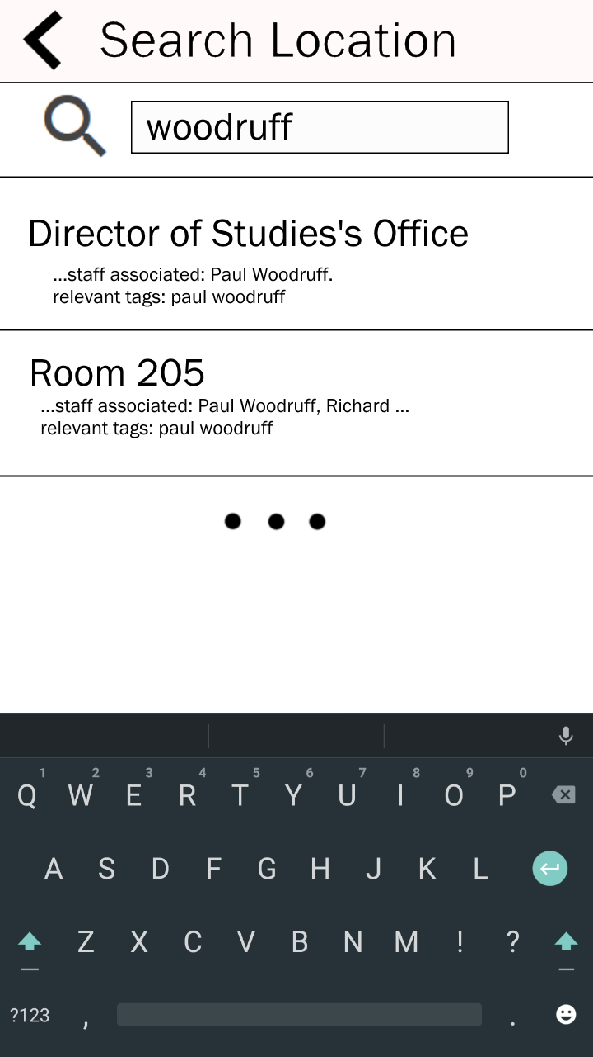

* Upon tapping a result listing, the node search returns the key of the node selected to whatever context called it, for example the Map View page would receive the key of the room and display it in the Node View pane. Afterwards, it returns to the previous page.

3.1.5 Node View

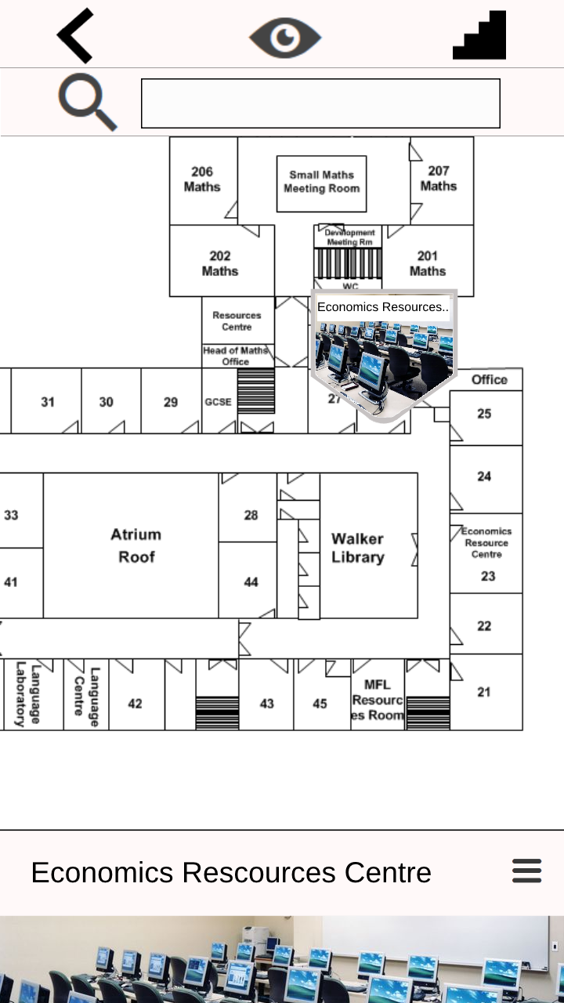 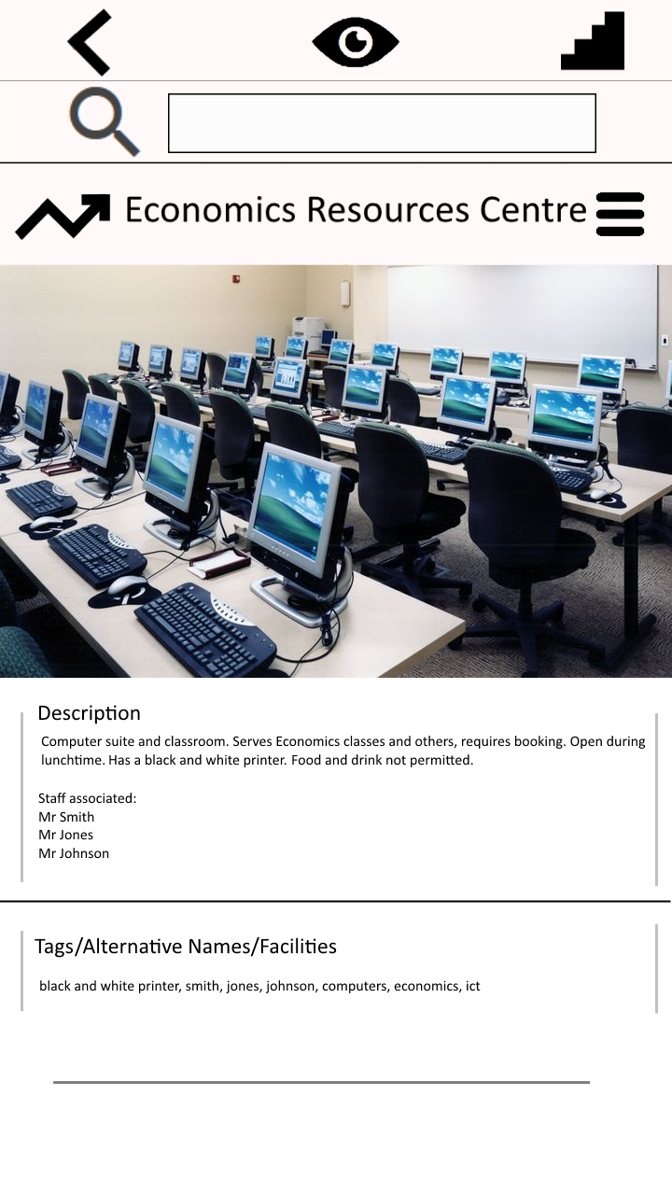

The Node View pane initially appears at the bottom of the page (left), forming a panel that can be dragged up (right). The pane features an image showing what the area looks like (the image specified in 1.1.3), followed by a editable text boxes containing the description of the area and the associated tags (the second and third elements respectively of the Description property of the node as described in section 1.1.1).

* Upon tapping the jagged arrow icon, the user is prompted to search for the source room; when this is selected, a route between the two rooms is generated and displayed on the **Route Display** page.

3.1.6 Route Display

The Route Display page shows the quickest route between origin (blue) and destination (red). The route is represented in green, and is drawn through nodes both invisible and visible (grey circular nodes); all other nodes are hidden.

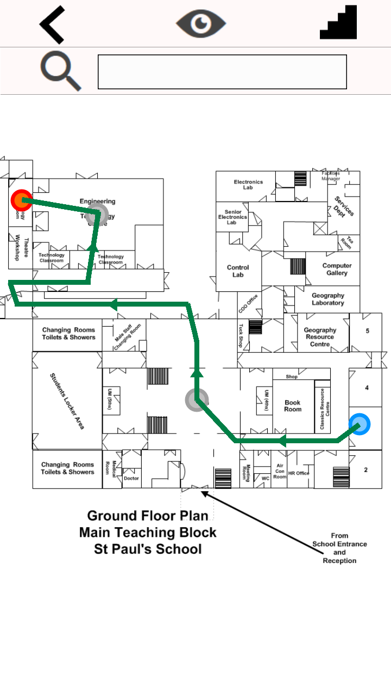

* Upon tapping a circular node, the app displays the respective **Node View** pane (albeit without jagged arrow icon, disallowing user from making a route within a route).
* Upon tapping the left arrow icon, the app returns to the **Map View** page.